**Expert ID/Name: Nstructive**

**Date: 11-Nov-2020**

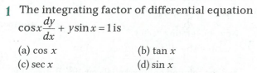

**Answer:**

|  |
| --- |
| MCQ Type Answers |

|  |
| --- |
| Choices |

|  |
| --- |
| Tips:  1 . Integrating factor of  is .  2. |

|  |  |  |  |  |
| --- | --- | --- | --- | --- |
| Correct Answer: (c)  Given: The differential equation is .  To find: Integrating factor of  Explanation:   |  |  | | --- | --- | | Instruction | Compare the differential equation with  Use the formula, | | Calculation |  | |
| Final Answer: Integral factor of  is. |